### ABSTRACT

This abstract introduces a Tours and Travel Management System designed to enhance operational efficiency for travel agencies. The system features intuitive customer registration interfaces, comprehensive hotel management, secure package sales processing, and streamlined offline transactions. The goal is to simplify the management of travel operations, optimize resource allocation, ensure secure and efficient customer data handling, and improve overall service delivery.

This system represents a significant advancement in addressing the evolving needs of the travel industry, contributing to the growth of travel businesses by offering a robust solution for managing customer and hotel information seamlessly. With secure data handling, efficient package management, and integration of advanced features, the system aims to provide a seamless and efficient experience for travel agency owners.

Emphasizing the integration of cutting-edge technologies, this system is poised to elevate the performance and customer satisfaction of travel agencies.

### ACKNOWLEDGEMENT

I wish to express my sincere thanks to The Principal Dr. Kaushal Prasad, HOD of Department of Master of Computer Applications Mr. Tejas V. Joshi for their support and for the facilities they have made available. I would also like to express my sincere gratitude to everyone for supporting me throughout my team project. First, I will thank my guide, Mrs. Minaxi Gurav for their enthusiasm, patience, insightful comments, helpful information, practical advice and unceasing ideas that have helped me tremendously at all times.

I am also grateful to the staff of Department of Master of Computer Applications for their consistent support and assistance. Finally, last but by no means least; I would thank my parents for their guidance and support on every step of mine, also to everyone in the Department of Computer Applications, it was great sharing premises with all of you during last 6 Months. Thanks for all your encouragement.

**TABLE OF CONTENT**

|  |  |  |
| --- | --- | --- |
| Sr no | Content | Page No |
| **1** | **Introduction** | 1 |
|  | 1.1 Background | 1 |
|  | 1.2 Objectives | 2 |
|  | 1.3 Purpose, Scope and Applicability | 3 |
| **2.** | **Survey Of Technologies** | 4 |
|  | 2.1 Existing Systems and its Limitations | 4 |
|  | 2.2 Proposed System | 5 |
| **3.** | **Requirements and Analysis** | 6 |
|  | 3.1 Requirement Specifications | 6 |
|  | 3.2 Planning And Scheduling – Gantt Chart | 7 |
|  | 3.3 Hardware Requirements | 8 |
|  | 3.4 Software Requirements | 8 |
|  | 3.5 Preliminary Product Description | 9 |
|  | 3.6 ER And UML Diagrams | 12 |
| **4.** | **System Design** | 21 |
|  | 4.1 Modules | 21 |
|  | 4.2 Data Design | 23 |
|  | 4.3 User Interface Design | 25 |
|  | 4.4 Test Cases Design | 31 |
| **5.** | **Future Enhancement** | 34 |
| **6.** | **Conclusion** | 35 |
| **7.** | **Bibliography** | 36 |

## INTRODUCTION

#### Background:

The Tours and Travel Management System in Java addresses the operational complexities faced by travel agencies in managing customer registrations, hotel partnerships, and offline package sales. In the dynamic travel industry, traditional methods of handling these tasks manually have proven inefficient and prone to errors. Thus, the development of a robust software solution becomes imperative to streamline operations and improve overall service delivery.

**Customer Registration**: Travel agencies traditionally maintain customer records manually, leading to challenges such as data redundancy and difficulty in accessing up-to-date information. By implementing a Java-based system, agencies can automate the customer registration process, enabling efficient capture of client details including preferences, travel histories, and contact information. This automation not only saves time but also enhances the ability to provide personalized travel services based on historical data.

**Hotel Registration:** Partnering with hotels is crucial for travel agencies to offer diverse accommodation options to customers. However, managing these partnerships manually can be cumbersome, leading to issues like inconsistent information and delays in updating rates and availability. The Tours and Travel Management System facilitates seamless hotel registration, allowing agencies to maintain a centralized database of partner hotels. This database can include detailed information on facilities, room types, pricing, and real-time availability, ensuring that agents can make informed decisions and provide accurate information to customers.

**Offline Package Sales:** Despite the growing prevalence of online bookings, many customers still prefer to finalize travel arrangements in person or via direct contact with travel agents. This preference necessitates the ability to handle offline sales efficiently. The Java-based management system supports offline package sales by providing agents with tools to create customized travel itineraries, calculate costs, and manage booking confirmations offline. This capability not only meets customer preferences but also enhances the agency's flexibility in accommodating varying customer needs and preferences.

#### Objectives:

#### 

#### The Tours and Travel Management System in Java is designed to enhance operational efficiency for travel agencies through several key objectives. Firstly, it aims to streamline customer registration by implementing a user-friendly interface that enables agency staff to register customers quickly and accurately. This includes capturing comprehensive customer profiles encompassing personal details, travel preferences, and contact information. By doing so, the system facilitates personalized service delivery, ensuring that agents can cater to individual customer needs effectively.

#### The system focuses on streamlined hotel registration by developing a centralized database for partner hotels. This database allows for seamless management of hotel information such as amenities, room types, rates, and availability. Real-time synchronization of updates ensures that travel agents have access to current and reliable data for efficient booking arrangements, thereby enhancing the overall booking process.

#### The system facilitates offline package sales by providing robust tools and functionalities. Travel agents are equipped with the capability to create customized travel itineraries, calculate costs, and manage bookings offline. This feature is crucial for serving customers who prefer or require direct interaction with agents, ensuring that transactions conducted offline are seamlessly synchronized with the system once connectivity is restored.

#### The system emphasizes enhanced operational efficiency by automating routine tasks involved in customer and hotel registration processes. Automation minimizes manual errors, improves data accuracy, and reduces turnaround time for customer inquiries and bookings. This efficiency enhancement enables travel agencies to operate more smoothly and allocate resources more effectively.

#### The system ensures integration and scalability by designing compatibility with existing IT infrastructure within travel agencies. It is built to accommodate future growth and expansion of services without compromising performance or data integrity. By adhering to robust security measures, including industry standards and regulations, the system protects sensitive customer and transactional data, ensuring confidentiality, integrity, and availability throughout its operations.

#### Purpose, Scope and Applicability:

**Purpose :**

The Tours and Travel Management System in Java is developed to streamline and enhance the operational efficiency of travel agencies. Its primary purpose is to facilitate seamless processes for registering customers, managing hotel partnerships, and facilitating offline sales of travel packages. By automating and centralizing these tasks, the system aims to improve service delivery, increase customer satisfaction, and optimize overall business performance within the travel industry.

**Scope :**

It includes features like streamlined customer registration, where agency staff can efficiently capture detailed customer profiles to personalize service delivery. Additionally, the system facilitates seamless hotel registration by maintaining a centralized database for partner hotels, ensuring up-to-date information on amenities, room types, rates, and availability. For offline operations, robust tools enable travel agents to manage package sales effectively, including the creation of customized itineraries and cost calculations, with synchronization to the main system post-offline transactions.

Automating routine tasks related to customer and hotel registration processes further enhances operational efficiency, minimizing errors and reducing turnaround times for customer inquiries and bookings, thereby optimizing resource utilization within the agency.

**Applicability:**

The Tours and Travel Management System in Java is designed to cater to a diverse range of stakeholders within the travel industry. It serves travel agencies of varying sizes seeking to streamline operations and enhance customer service through efficient registration processes and personalized service offerings.

Hotel partners benefit from the system's ability to maintain centralized, real-time information on amenities and availability, fostering seamless collaboration with travel agencies. Travel agents find the system indispensable for managing offline package sales, providing them with tools to create customized itineraries and handle bookings efficiently, whether online or offline.

Ultimately, the system enhances the overall booking experience for customers by ensuring accurate and up-to-date travel information and personalized service recommendations tailored to individual preferences and needs.

### SURVEY OF TECHNOLOGIES

#### Existing System:

The current landscape of travel management systems often relies on fragmented software solutions that may not fully integrate all aspects of customer management, hotel registration, and offline package sales. Typically, these systems involve multiple platforms for customer databases, hotel partnerships, and booking management, leading to inefficiencies and data discrepancies. Manual processes for customer and hotel registration can result in errors, delays in updating information, and challenges in providing real-time availability to customers. Offline sales processes often lack synchronization with the main system, impacting operational transparency and customer service.

#### Limitations:

• Fragmented software solutions lead to integration challenges.

• Manual data entry results in errors and delays in updates.

• Limited offline capability hampers seamless operations.

• Scalability issues restrict system growth.

• Insufficient security measures pose data vulnerability risks.

#### Proposed System

The proposed Tours and Travel Management System in Java aims to address these limitations by leveraging integrated technologies to streamline operations and enhance service delivery. Key features of the proposed system include:

**Integrated Customer Registration:** Implementing a unified platform with a user-friendly interface for swift and accurate customer registration. This includes capturing comprehensive profiles with personal details, travel preferences, and contact information, facilitating personalized service offerings.

**Centralized Hotel Registration:** Developing a centralized database for partner hotels to manage and update information such as amenities, room types, rates, and real-time availability. This ensures that travel agents have access to current and reliable data for seamless booking arrangements.

**Package Sales Management:** Providing robust tools and functionalities for managing offline package sales. Travel agents can create customized travel itineraries, calculate costs, and process bookings offline, with automatic synchronization to the main system once connectivity is restored.

**Automation for Operational Efficiency:** Automating routine tasks related to customer and hotel registration processes to minimize errors and improve efficiency. This includes reducing turnaround times for customer inquiries and bookings, optimizing resource utilization within the agency.

**Scalability and Integration:** Designing the system to be scalable, accommodating future growth and expansion of services without compromising performance. Ensuring seamless integration with existing IT infrastructure within travel agencies to enhance compatibility and operational continuity.

**Enhanced Security and Compliance:** Implementing robust security measures to protect sensitive customer and transactional data. Adhering to industry standards and regulations to maintain confidentiality, integrity, and availability of information throughout the system.

**By adopting these technologies and functionalities, the proposed Tours and Travel Management System in Java aims to significantly improve operational efficiency, enhance customer satisfaction, and foster growth opportunities for travel agencies in a competitive market environment.**

### REQUIREMENTS AND ANALYSIS

#### Project Definition:

This project aims to develop a Tours and Travel Management System in Java, designed to modernize and streamline operations for travel agencies. Leveraging advanced technologies, the system will facilitate efficient customer registration, seamless hotel management, and effective offline package sales. Key objectives include automating customer and hotel registration processes, enhancing data accuracy, and optimizing resource utilization.

The system will feature a user-friendly interface for swift and accurate customer registration, capturing comprehensive profiles including personal details, travel preferences, and contact information. It will also include a centralized database for partner hotels, ensuring real-time management of amenities, room types, rates, and availability updates to support timely booking arrangements.

Offline package sales capabilities will enable travel agents to create customized itineraries, calculate costs, and manage bookings offline, with synchronization to the main system upon reconnection. The project will adhere to agile development methodologies, ensuring flexibility to adapt to evolving requirements and industry standards.

Deliverables will include a scalable system architecture capable of accommodating growth and geographic expansion, accompanied by comprehensive documentation. The expected impact includes improved operational efficiency, enhanced customer satisfaction through personalized service offerings, and a strengthened position for travel agencies in the competitive travel market.

# Work Breakdown Structure of Our Project

**GANTT CHART**

**Preliminary Investigation**

Proposed Time Actual Time

**System Analysis**

**System Design**

**System Coding**

**Testing & Validation**

**Report Generation & Submission**

7

**F e b M a r c h A p r i l M a y**

#### 3.4 Software and Hardware Requirements

##### Software Used:

Front end: JAVA, Java AWT Jar Files.

Back end: XAMMP Apache / MySql

Operating System: Windows 8 or above.

##### Hardware Used:

Processor: Intel Core i5 Memory: 4 GB RAM

Storage: Minimum 5GB of Hard disk Space.

##### Tools Used:

Apache Net Beans IDE 21

STAR UML Diagram Tool WPS Office / MS Word (Documentation)

#### 3.5 Project Description:

##### User Module

##### Registration: Users can register with the system by providing personal details, contact information, and travel preferences.

##### Profile Management: Users can view and update their profiles, including preferences and past travel history.

##### Search and Booking: Users can search for hotels based on criteria such as location and amenities. They can view hotel details and make bookings.

##### Package Booking: Users can explore and book travel packages offered by the travel agency, with options for customization based on preferences.

##### Payment Integration: Integration with payment gateways for secure online transactions.

##### Admin Module:

* + The admin module will be accessible only to authorized personnel.
  + Admins can log in securely to the admin dashboard.

The dashboard will allow admins to manage the product inventory by adding new items, removing outdated products, and updating existing product information.

##### Conceptual Model

**Submit/Register me/Add:**

By clicking this button data is stored on server and all the controls get refreshed and cleared. Then it will be ready for new record.

##### Clear/Back/Cancel:

By clicking this button all the controls get refreshed and cleared. Then it will be ready for next record to enter.

##### Login:

Used for logging in to particular account.

##### Search:

Used for logging in to particular account.

##### First/Next/Previous/Last:

Navigate to first/next/previous/last record in the particular form

##### Update/save changes:

This button is used to update the records/profiles.

##### Delete:

Admin can delete data and user can delete its account by clicking this button.

##### Pre-Flow Charts & System Flow Charts

Following symbols used to draw system flowchart :-

1. Used for process
2. Used for predefined process
3. Used for documents
4. Used for manual operation
5.  Used for online storage
6.  Disk or direct access file
7. Used for manual input
8. Used for display

Admin

Update Customer

Book Hotel

LOGIN

Add

Customer

Check

End

#### Entity Relationship Diagram :-

An entity relationship diagram (ERD) shows the relationships of entity sets stored in a database. An entity in this context is a component of data. In other words, ER diagrams illustrate the logical structure of databases.

##### Common Entity Relationship Diagram Symbols

An ER diagram is a means of visualizing how the information a system produces is related.

There are five main components of an ERD:

* 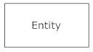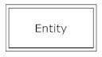**Entities**, which are represented by rectangles. An entity is an object or Concept about which you want to store information.
* 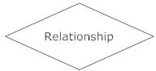**Actions**, which are represented by diamond shapes, show how two Entities share information in the database.
  + **Attributes**, which are represented by ovals. A key attribute is the unique, distinguishing characteristic of the entity. For example, an employee's social security number might be the employee's key attribute.

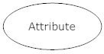

* **Connecting lines**, solid lines that connect attributes to show the relationships of entities in the diagram.
* **Cardinality** specifies how many instances of an entity relate to one instance of another entity.

##### Entity Relationship Diagram :-

1

Many

1

1

1

1

Many

Many

Many

1

1

1

1

Many

Many

Many

books

has

has

books

maintain

maintain

manage

manage

manage

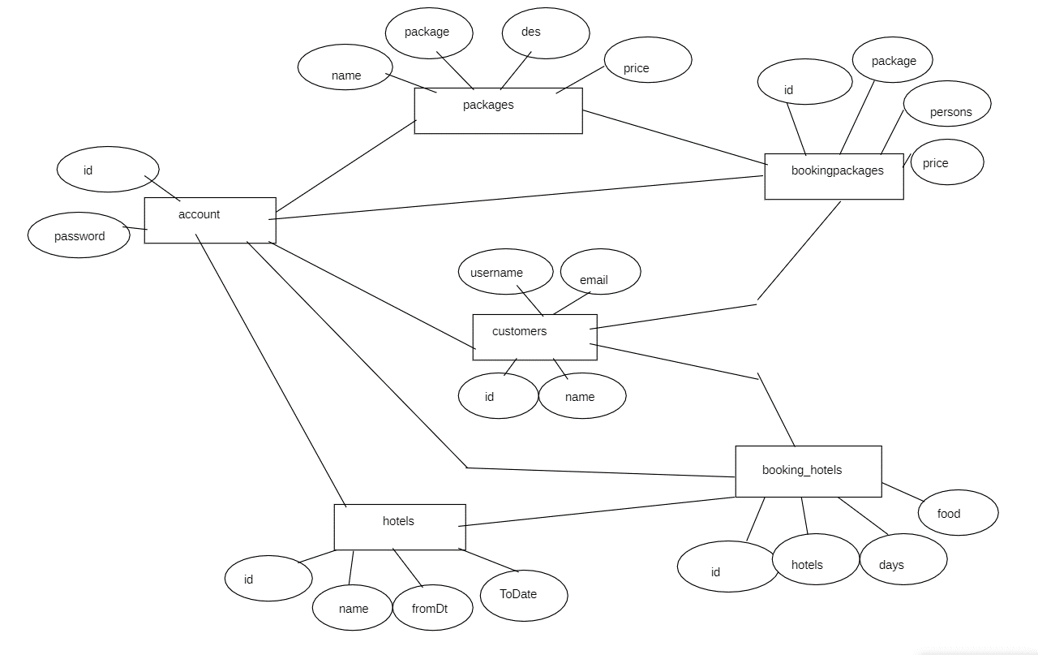

**Class Diagram :-**

A class diagram models the static structure of a system. It shows relationships between classes, objects, attributes, and operations.

##### Basic Class Diagram Symbols and Notations :-

**Classes**

Classes represent an abstraction of entities with common characteristics. Associations represent the relationships between classes.

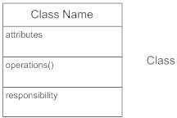

##### Active Classes

Active classes initiate and control the flow of activity, while passive classes store data and serve other classes. Illustrate active classes with a thicker border.

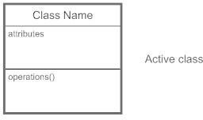

##### Visibility

Use visibility markers to signify who can access the information contained within a class.

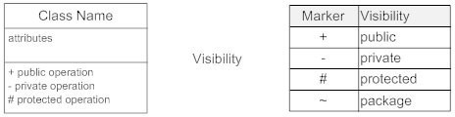

##### Associations

Associations represent static relationships between classes. Place association names above, on, or below the association line.

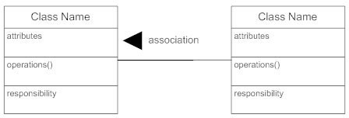

##### Multiplicity (Cardinality)

Place multiplicity notations near the ends of an association.

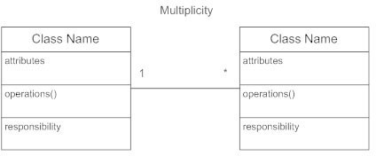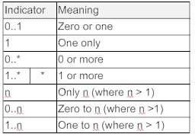

##### Constraint

Place constraints inside curly braces {}.

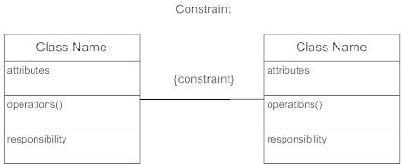

##### Class Diagram:

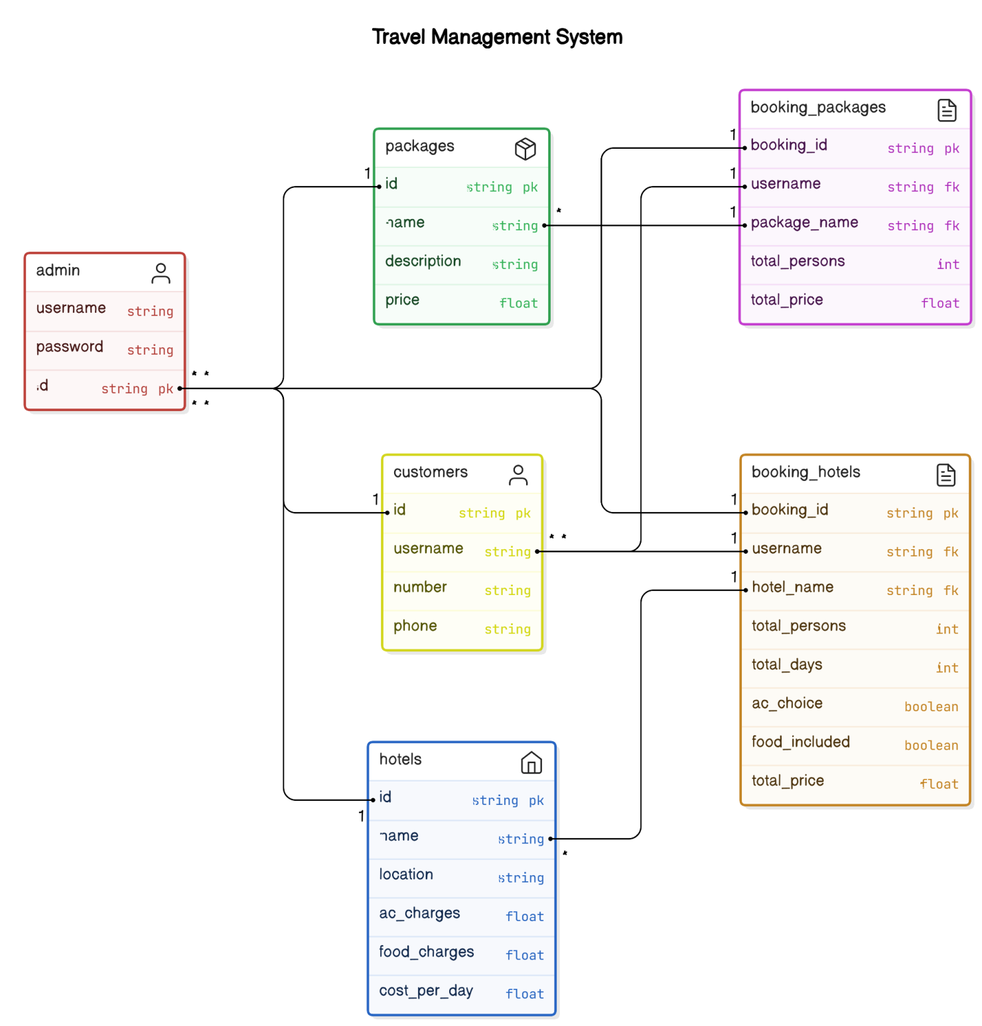

**Use Case Diagram: -**

A UML use case diagram is the primary form of system/software requirements for a new software program under developed. Use cases specify the expected behavior (what), and not the exact method of making it happen (how).

Use cases once specified can be denoted both textual and visual representation (such as UML). A key concept of use case modeling is that it helps us design a system from end user's perspective. It is an effective technique for communicating system behavior in the user's terms by specifying all externally visible system behavior.

**Purpose of Use Case Diagram**

Use case diagrams are typically develop in early stage of development and people often apply use case modelling for the following purposes:

* + Specify the context of a system
  + Capture the requirements of a system
  + Validate a systems architecture
  + Drive implementation and generate test cases
  + Developed by analysts together with domain experts

**Actor**



* + Someone interacts with use case (system function).
  + Named by noun.
  + Actor plays a role in the business
  + Similar to the concept of user, but a user can play different roles
  + For example:

A prof. can be instructor and also researcher plays 2 roles with two systems

* + Actor triggers use case(s).
  + Actor has responsibility toward the system (inputs), and Actor have expectations from the system (outputs)

**Use Case:**

Use case

* + System function (process - automated or manual)
  + Named by verb + Noun (or Noun Phrase).
  + i.e. Do something
  + Each Actor must be linked to a use case, while some use cases may not be linked to actors.

**Communication Link:**

The participation of an actor in a use case is shown by connecting a actor to a use case by a solid link.

Actors may be connected to use cases by associations, indicating that the actor and the use case communicate with one another using messages.

**Boundary of system:**

System

The system boundary is potentially the entire system as defined in the requirements document. For large and complex systems, each modules may be the system boundary. or example, for an ERP system for an organization, each of the modules such as personal, payroll, accounting, etc.

##### Use Case Diagram:

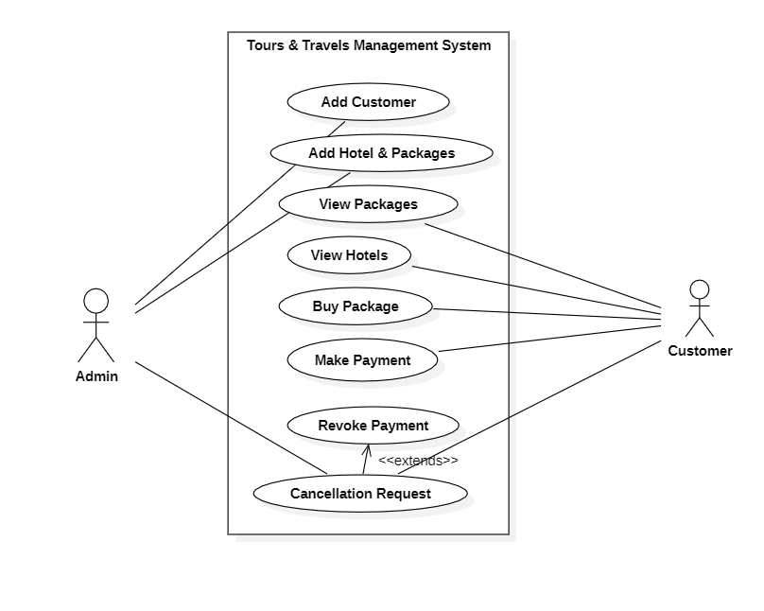

**Flow Diagram :-**

A flow diagram is a visual representation that outlines the sequence and steps involved in a process or system. It consists of various elements such as nodes, arrows, and connecting lines that illustrate the progression from one stage to another. Each node typically represents a specific task, decision point, or event, while arrows indicate the direction or flow of the process.

At its core, a flow diagram serves several purposes:

1. **Process Visualization:** It provides a clear, structured view of how activities or tasks are interconnected within a larger framework.
2. **Step-by-Step Sequence:** It breaks down complex processes into manageable steps, showing the logical order of operations.
3. **Decision Points:** It highlights key decision-making moments or branches in the process flow, where different paths or outcomes might occur.
4. **Efficiency Analysis:** It helps identify inefficiencies, bottlenecks, or areas for improvement within the process.

**Flow Diagram:**

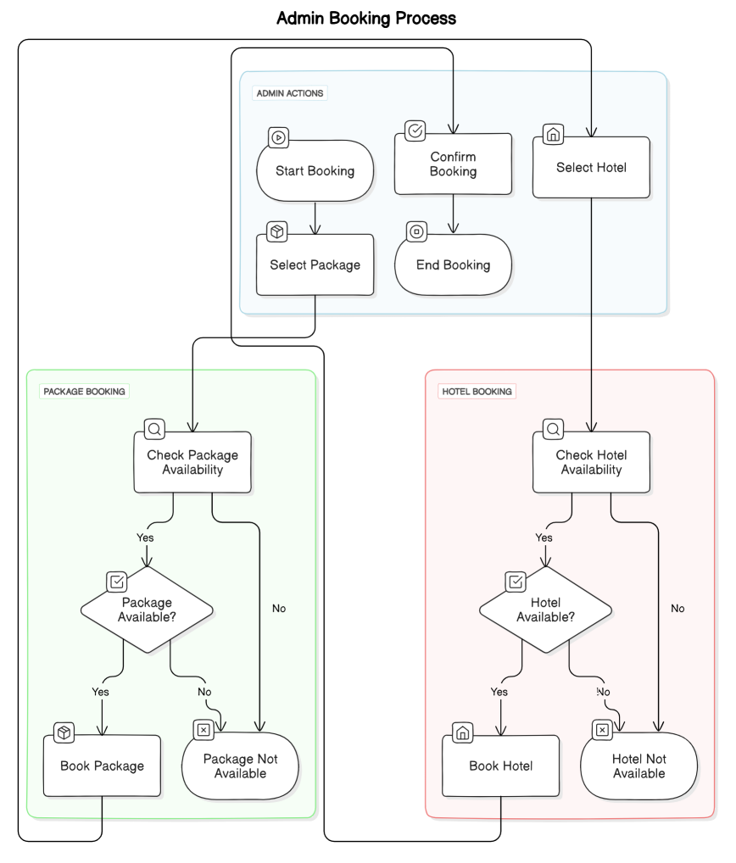

**4.1 Basic Modules:**

### SYSTEM DESIGN

Offline Tours and Travel Management System provides the module:

Admin

User

##### Manager / Admin:

In this module, admin can input record about hotels, users and packages. Admin can modify records and viewing changed record. Admin can login systems and handled the System pages.



Log In

Handled the System

Update and Modify

View details about

#### User:

In this module, customer or users can came to the particular owner of the company and ask for the particular package or particular hotel want to travel.

.



View Package Details

Verify details

Purchase it

Customer

Visits

##### 4.2 Schema Design

**Admin Login**

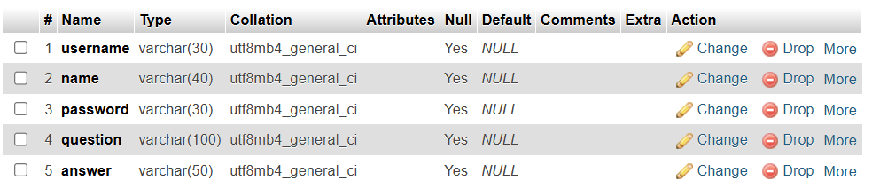

**Customer**

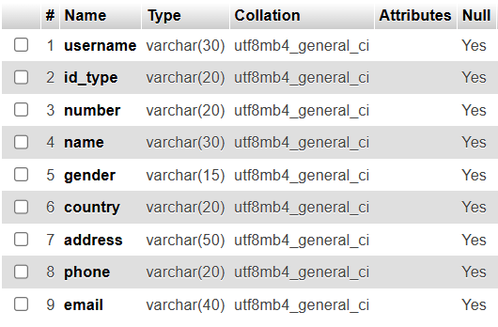

**Hotel**

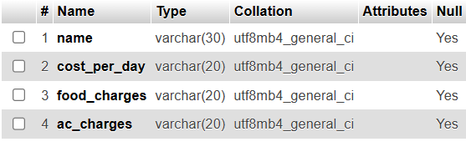

**Book Hotel**

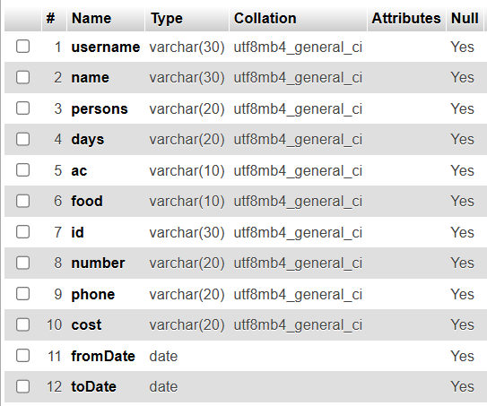

**Book Package**

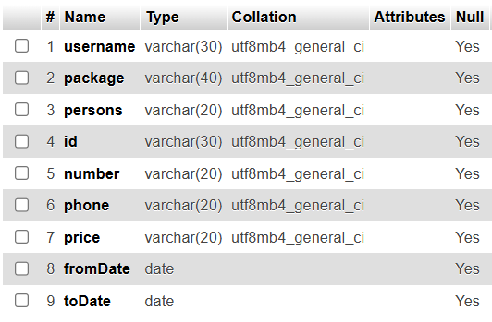

**4.3 Structural Overview of Our System**

**Home page**

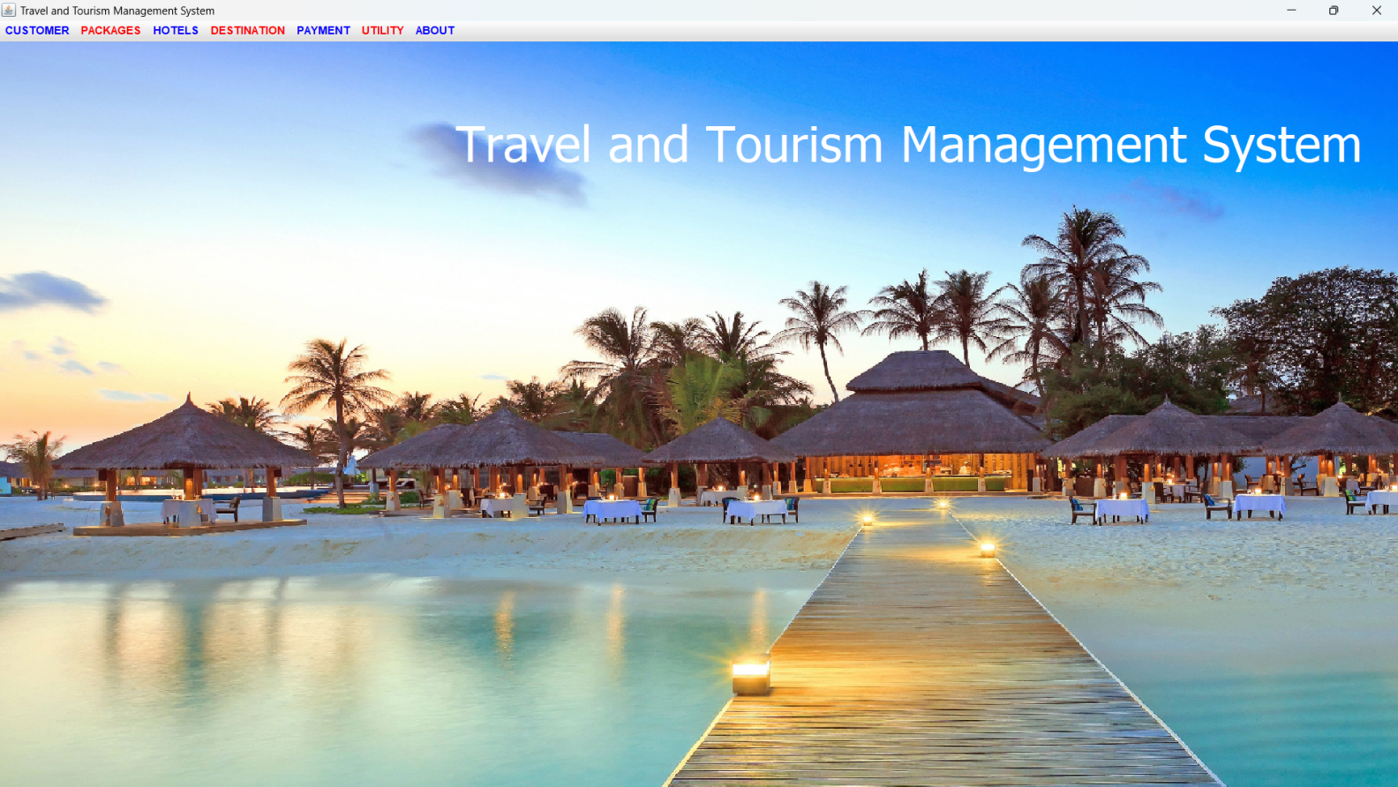

**Admin login**

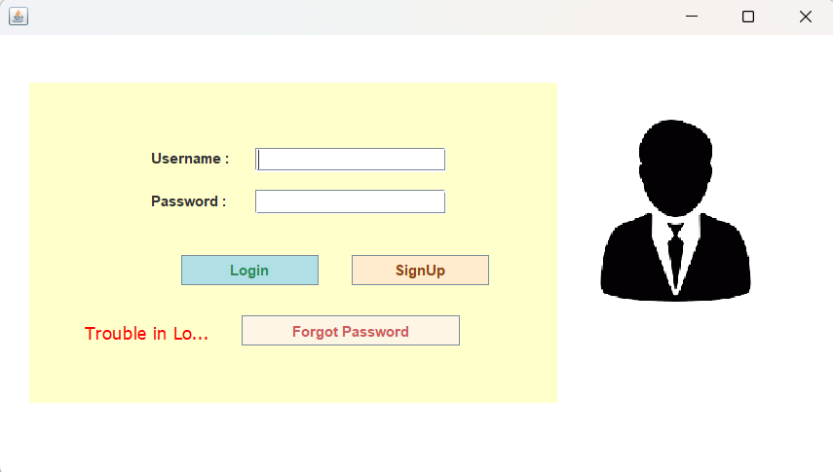

**Add Customer :**

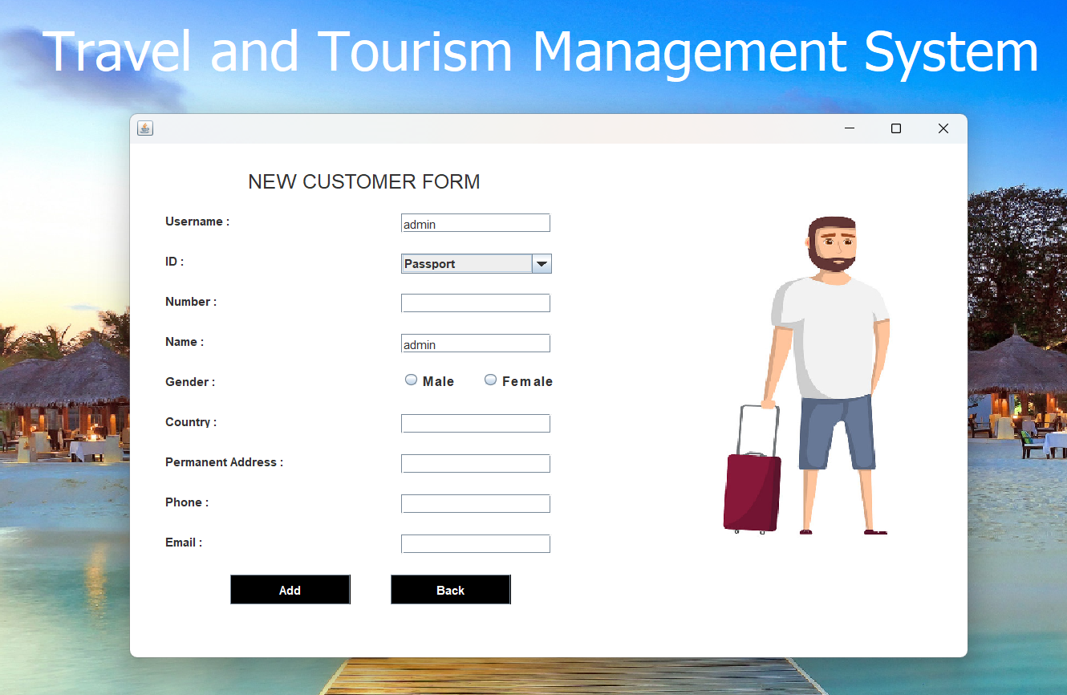

**Update Customer :**

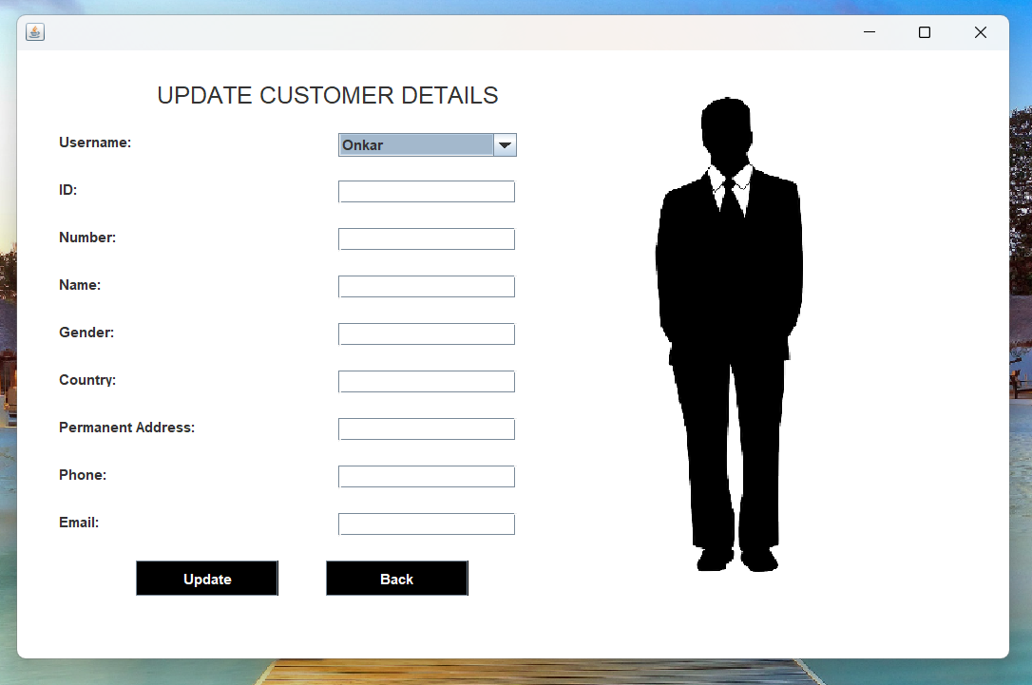

**View Customer Details :**

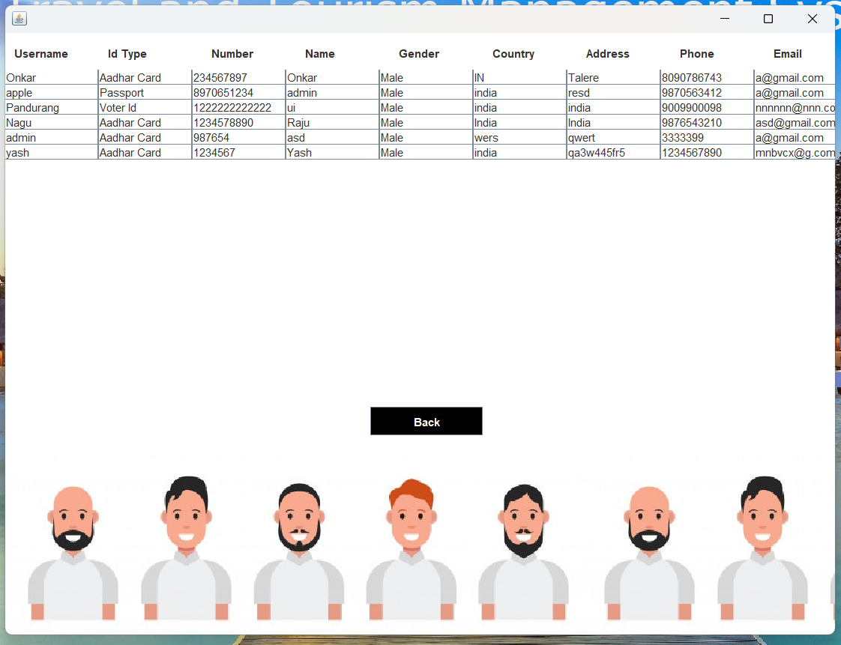

**Delete Customer :**

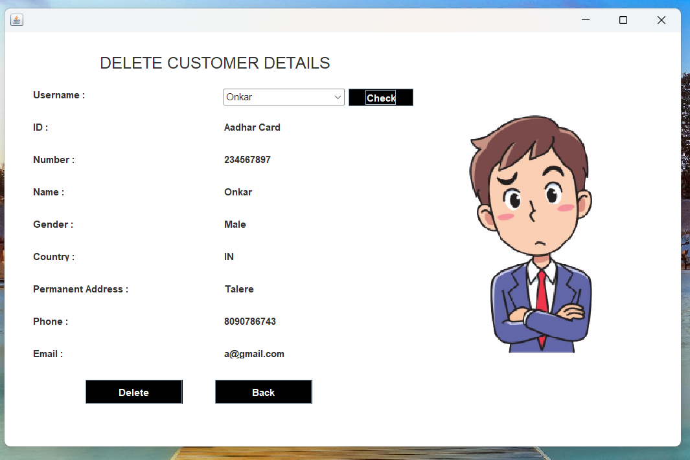

**Book Package**

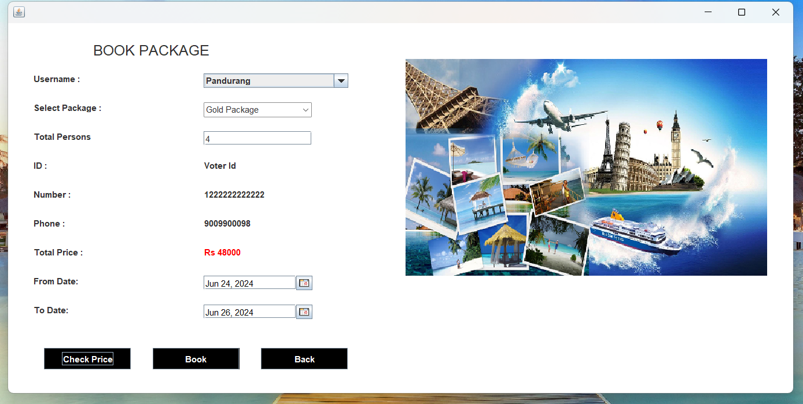

**Book Hotel**

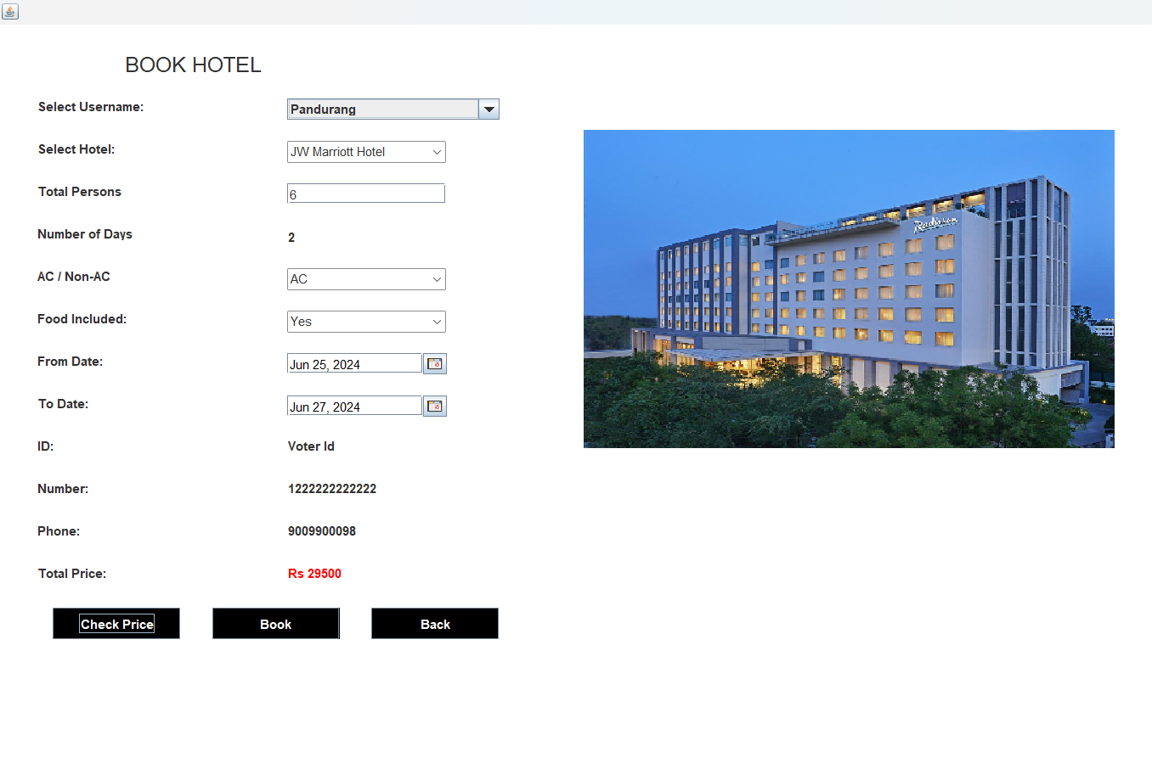

**Bill of Package:**

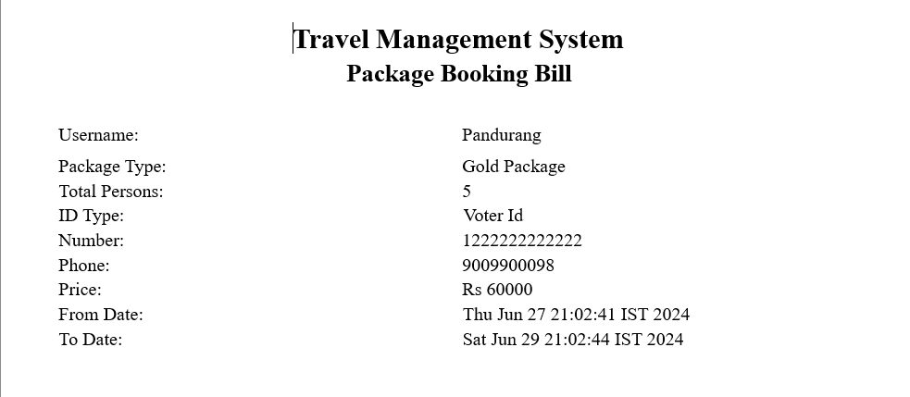

**Bill of Hotel Booking:**

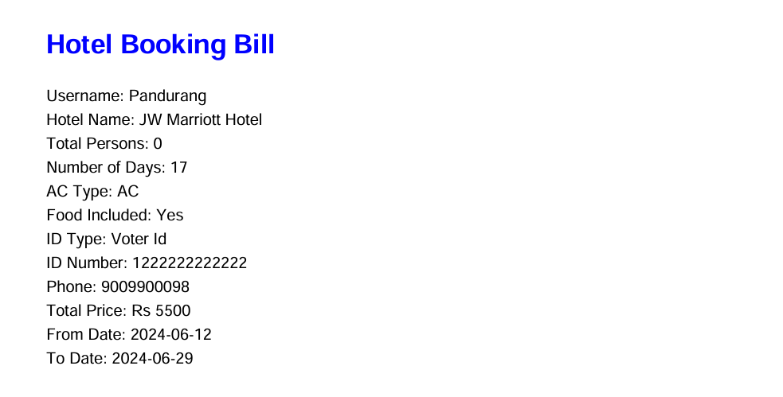

**SECURITY ISSUES**

#### Most common security issues are applicable for the project:

SQL Injection System Failure Power Cuts Hardware Failure

**Test Case Design:**

|  |  |  |  |  |  |  |  |
| --- | --- | --- | --- | --- | --- | --- | --- |
| Req no | Requirement | Test Case No | Description | Preconditions | Steps | Expected Output | Result |
| 1 | Admin Login | T.C no.1.1 | Verify that a registered admin can log in | The user is on the admin page | 1. Enter a valid username.  2. Enter a valid password.  3. Click the "Login" button. | The admin is logged in successfully and redirected to the dashboard. | True |
|  |  | T.C no.1.2 | Invalid Username and Valid Password can login |  | 1. Enter a invalid username/email.  2. Enter a valid password.  3. Click the "Login" button | After Clicking login the invalid Username& valid Password error message should be displayed. | Fail |
|  |  | T.C no.1.3 | Valid Username and Invalid Password can login |  | 1. Enter a valid username.  2. Enter a invalid password.  3. Click the "Login" button | After Clicking login the valid Username& invalid Password error message should be displayed | Fail |
|  |  | T.C no.1.4 | Invalid Username and Invalid Password can login |  | 1. Enter a invalid username.  2. Enter a invalid password.  3. Click the "Login" button | After Clicking login the invalid Username& invalid Password error message should be displayed | Fail |
|  |  | T.C no.1.5 | Redirect |  | 1. Enter a valid username.  2. Enter a invalid password.  3. Click the "Login" button | After clicking login if it does not redirect to dashboard | Fail |
| 2 | Add Customer | T.C no.2.1 | Verify that a new customer can successfully added | The customer is on the Add customer page | 1. Enter a valid username.  2. Enter a valid Id.  3. Enter a valid number.  4. Enter a valid Name.  5. Enter a correct Gender.  6. Enter a correct Country.  7. Enter a valid permanent address.  8. Enter valid Phone number.  9. Enter a valid email address.  10. Click the "Add" button. | The customer is added successfully. | True |
|  |  | T.C no 2.3 | If the customer details are invalid |  | 1. Enter a invalid username.  2. Enter a invalid Id.  3. Enter a invalid number.  4. Enter a invalid Name.  5. Enter a incorrect Gender.  6. Enter a incorrect Country.  7. Enter a invalid permanent address.  8. Enter invalid Phone number.  9. Enter a invalid email address.  10. Click the "Add" button | The should not be added. | Fail |
| 3 | Update Customer Details | T.C no. 3 | If the customer wants to update his/her details than he can update it | The Customer is on the Update Customer Details | 1. Enter a valid username.  2. Enter a valid Id.  3. Enter a valid number.  4. Enter a valid Name.  5. Enter a correct Gender.  6. Enter a correct Country.  7. Enter a valid permanent address.  8. Enter valid Phone number.  9. Enter a valid email address.  10. Click the "Add" button. | The customer details are updated successfully. | True |
| 4 | Book Package | T.C no.4 | Verify that a customer can book the package | The customer is on the Book Package page | 1. Enter username  2. Select the package.  3. Enter total Persons  4. Valid id  5. Enter valid number  6. Enter valid phone number  7. Display total amount.  8. Enter arrival date  9. Enter Departure date  10. Click Book | After entering the booking package details it will successfully book the package. | True |
| 5 | Book Hotel | T.C. no. 5 | Verify that a customer can book the Hotel | The customer is on the Book Hotel page | 1. Enter username  2. Select the Hotel.  3. Enter total Persons  4. Enter Number of days  5.AC/Non-AC  6. Food included  7. Enter arrival date  8. Enter Departure Date  9. Valid Id  10.Number  11. Phone no.  12. Total amount.  13.Click Book | After entering the booking hotel details it will successfully book the hotel. | True |
| 6. | Cancel a Booking | T.C. no 6 | Verify that a customer can cancel a booking | The customer has an active booking. | Click the "Cancel" button. | The booking is canceled successfully | True |
| 7. | Bill Generation | T.C. no 7 | The Bill of package and hotel is generated. | The bill of package and hotel is generated. | Bill dispay | After clicking the book button the bills of package and hotel will be generated | True |
| 8. | Reset Password | T.C. no 8 | Verify that a admin can reset the password | The customer is on the login page | 1. Click the "Forgot Password" .button  2. Answer the Security Question.  3. Click "Submit". | The Admin can reset their password successfully. | True |

**Future Enhancement**

* The project we have done on the Tours and Travel Management System offline system we think on it and building online prototype of it.
* The project now contains limited number of packages and hotels we want to expand them.
* The project has no any type of private car rental service or private destination model will add it on this project if it works properly with our system goals.

### CONCLUSION

This project was actually a great opportunity for growth of myself and I enjoyed every single period of work. The task took more time to the different parts of the project development and gave its genuine understanding. The struggle and challenges faced by me during the project development was life learning and will always be our actual guide for future. I had put all my best to perform the project.

The project is running effectively and agreeably to satisfy the clients expectations. During the task advancement I truly understood the betterments and facilities those might have been given to upgrade the venture. I look at them as future improvements.

### BIBLIOGRAPHY

1. https://[www.tutorial-point.com](http://www.c-sharpcorner.com/)
2. https://[www.stackoverflow.com](http://www.stackoverflow.com/)
3. https://[www.w3school.com](http://www.w3school.com/)
4. https://[www.java2s.com](http://www.aspsnippets.com/)
5. https://[www.codeproject.com](http://www.codeproject.com/)